Date: 11.03.2016
Publication: Catholic Religious Australia
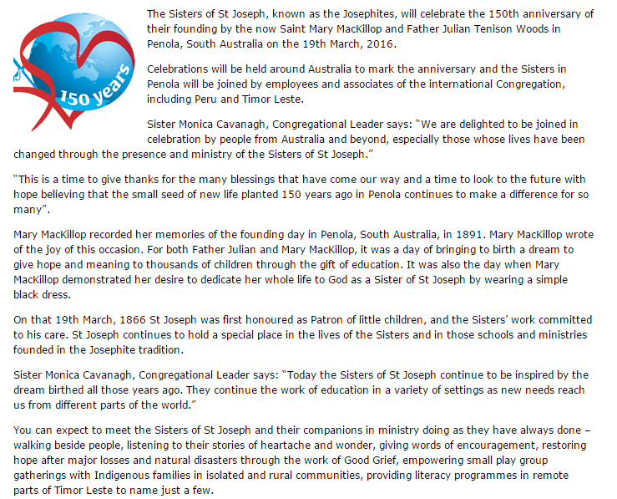
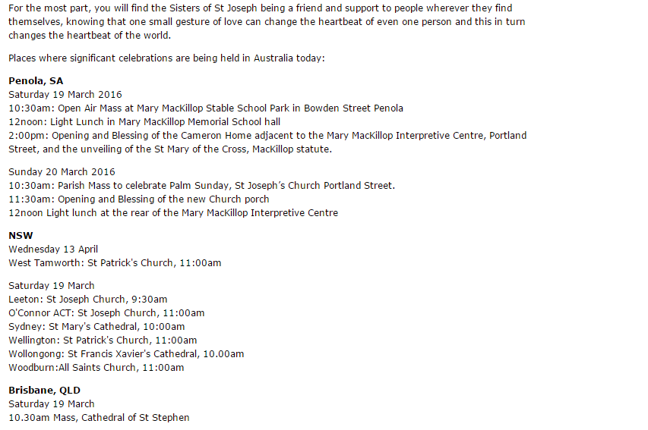
http://www.catholicreligiousaustralia.org.au/index.php/news-a-views/news/item/2087-join-josephites-celebrations-marking150-years-of-service

