Date: 11.03.2016
Publication: Central Western Daily
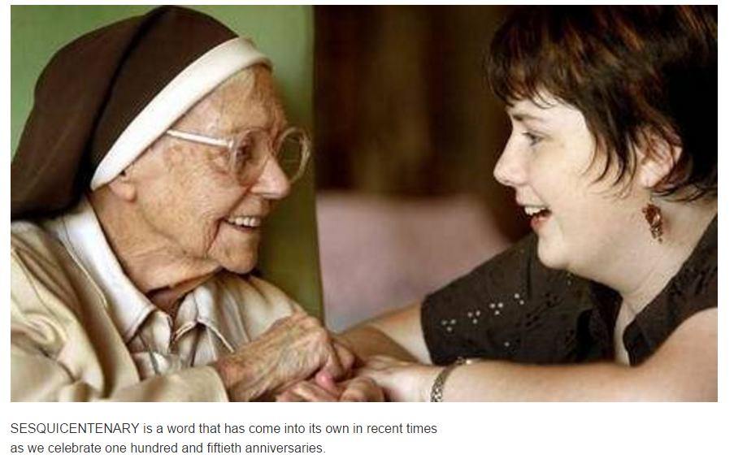
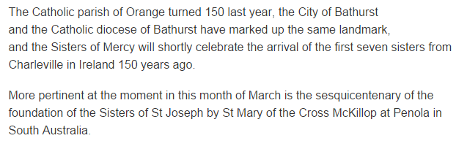
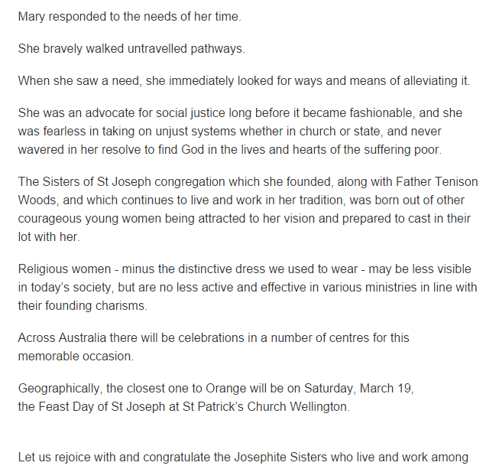
http://www.centralwesterndaily.com.au/story/3781922/sister-mary-hail-mary-for-the-sisters-of-st-joseph-celebrating-150-years/

