Date: 12.03.2016
Publication: Sydney Catholic
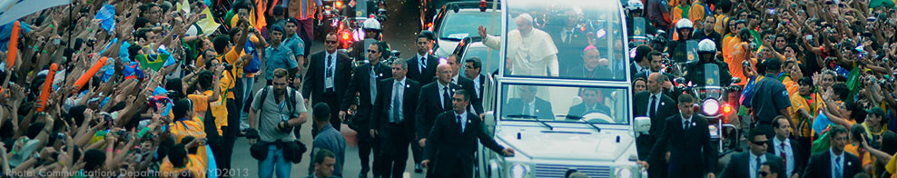
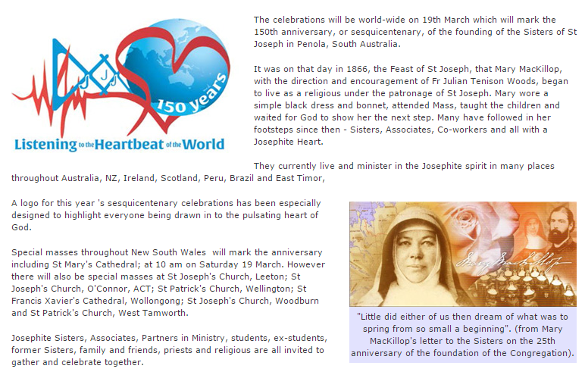

https://www.sydneycatholic.org/news/latest_news/2016/2016212_603.shtml

