Date: 12.03.2016
Publication: Sydney Catholic
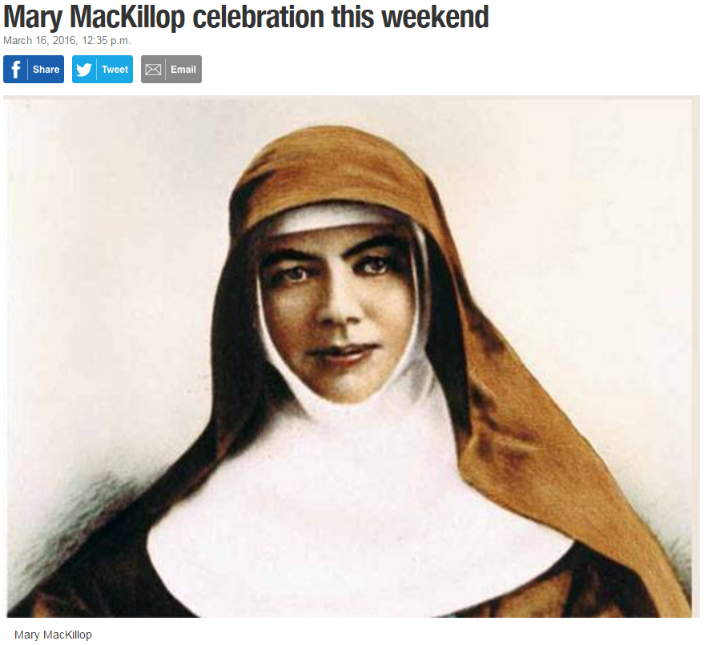
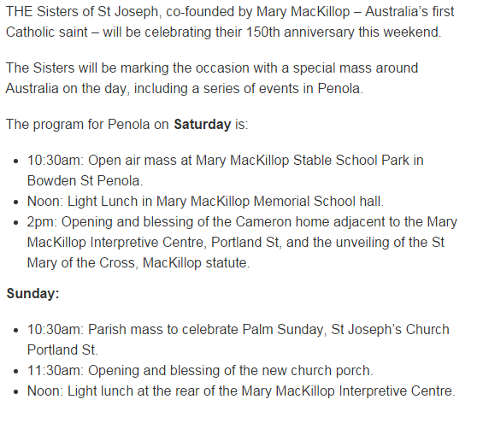
http://www.naracoorteherald.com.au/story/3794431/mary-mackillop-celebration-this-weekend/?cs=1488

